

ACKNOWLEGEMENT

I would like to express my sincere thanks to my teacher for guiding me throughout this project. Their support, valuable suggestions, and encouragement helped me to understand the concepts clearly and complete the project successfully. I am grateful for their time and effort in helping me improve my work.

I would also like to thank my college for giving me this opportunity to work on such a useful project. It helped me learn practical knowledge and improve my programming skills. I also thank my friends and classmates for their help and support during the project.

Lastly, I am thankful to my family for their constant encouragement and motivation, which helped me complete this project on time.

🏥 HOSPITAL APPOINTMENT BOOKING SYSTEM
📘 DETAILED PROJECT REPORT

1. ABSTRACT
The automated Hospital Appointment Booking System is a means of facilitating the scheduling of appointments between the patient and physician. The manual method of scheduling appointments in hospitals has the potential to introduce long waits due to scheduling conflicts, double-booked appointments, and poorly managed records.
The system has been created using the Object-Oriented Programming (OOP) format, in the Java programming language. The Hospital Appointment System is designed to maintain both the physician and patient records. The system allows users to schedule, cancel and review appointments.
The primary objectives of the system include improved efficiency in the scheduling process, reduction of manual errors and a systematic procedure for scheduling appointments. The system also provides examples of real-world applications of OOP concepts, including encapsulation, abstraction and interaction amongst objects.
_______________________________________________________________

2. INTRODUCTION
In the field of healthcare today, completing appointment scheduling in a timely manner is critically important for providing patient care and optimizing the use of time. Hospitals see thousands of patients daily; therefore, managing appointments manually can create high risk for error and misinterpretation.
It is necessary to implement a computerized system to enable the automation of the scheduling process, and thereby reduce the potential for error in scheduling. This project will create the computerized Hospital Appointment Booking System with the use of Java. The system will enable users to schedule an appointment, check availability and cancel an appointment.
The use of Object-Oriented Programming is essential for building these systems. By utilizing multiple classes to break down the classes into their individual parts, it allows more flexibility for the Programmer to write their respective programs and implement OOP principles.
3. Methodology
- Requirement Analysis
- System Design
- Coding in Java
- Testing

4. Objectives of the Project
- Design a computerized booking system
- Minimize the risk of errors due to manual scheduling
- Afford facilities to book appointments, verify the schedule and cancel appointments
- Afford effective utilization of time and effort
- Apply the principles of Object Oriented Programming like classes and objects
- Develop a user-friendly booking system
_________________________________________________________________________________

5. Scope
- Can be applied to small scale hospitals and clinics.
- Facilitates efficient appointment scheduling.
- Avoids errors and overlapping appointments.
- Can book, cancel, and view appointments.
- Example illustrating Object Oriented Programming (OOP) concepts
_________________________________________________________________________________

6. System Requirements
- Hardware: Computer with 4 GB RAM
___________________________________________________________________________

7. Implementation
The system is implemented using Java classes and arrays. Methods are used for booking, cancellation, and display operations.
Different Classes Explained (Logic):
1. Doctor Class:
A Doctor Class will allow you to store and manage the details of all doctors, including their doctor ID, name, and type of doctor. A Doctor has an ID to allow for assigning appointments for the Hospital Appointment Booking System.
2. Patient Class:
Patient Class contains unique identification numbers (ID), first names, last names, age, and other relevant information about each patient in Hospitals Appointment Booking System.

3. Appointment Class
Appointment Class acts as a connector between Doctor Class and Patient Class; in addition, there is appointment date/time and status of the appointment for each of them. Booked appointments and the ability to tell whether or not they are still active through Appointment Class.

4. Appointment Manager Class
The Appointment Manager is responsible for scheduling all appointments in the Hospitals Appointment Booking System. Examples of functionality of Appointment Managers include:
* Checking availability of time slots in the Hospitals Appointment Booking System
* Creating on the Hospitals Appointment Booking System
* Cancelling of appointments in the Hospitals Appointment Booking System
* Displaying all existing appointments in the Hospitals Appointment Booking System

The Appointment Manager is responsible for ensuring that no appointment is created more than once by a patient/doctor at any time through the Hospitals Appointment Booking System

INPUT
===== Hospital Appointment System ==== =
1. Book Appointment
2. View Appointments
3. Exit
Enter your choice:

OUTPUT
Enter your choice: 1
Enter Patient ID: 15
Enter Patient Name: SAM
Enter Age: 25
Enter Appointment ID: 25
Enter Doctor Name: NEETISH
Enter Date: 16
Appointment Booked Successfully!

8. Flow Chart

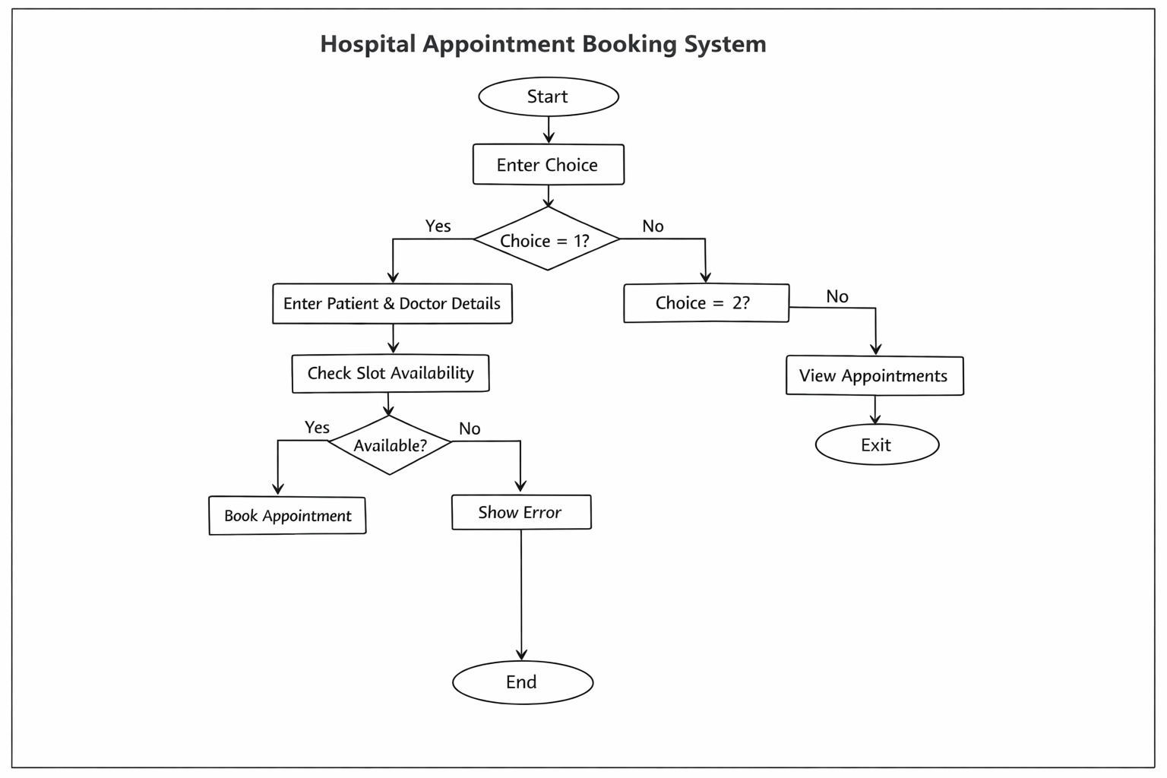
_________________________________________________________________________________

9. Gantt Chart
1. Planning & Structure
Aspect Description

Purpose To break down projects into many different areas or components
ie; design; coding; testing; documentation)
Function Helps create timeline for how long each task should take
Importance Provides project the structure necessary to allow project to be
considered and completed
Need for Planning Projects can be re-engineered or modified, but even with an
existing project, a designer will always need to plan properly

2. Time Management
The Gantt chart also helps in managing time effectively. It clearly shows:
- When each task starts
- When each task should be completed
This helps in completing the project within the given time and avoids delays or last-minute panic. It also ensures that enough time is given to important stages like coding and testing.
Task | Timeline
Requirement Analysis | Day 1
Planning & Structure | Day 1 – Day 2
System Design | Day 2
Coding / Implementation | Day 2 – Day 3
Testing | Day 3 – Day 4
Documentation | Day 4 – Day 5

10. Conclusion
This project demonstrates that an Object-Oriented Language (OOP) is able to resolve the scheduling difficulties at a Hospital.
_______________________________________________________________

11. References
Programming in Java by Herbert Schildt
GeeksforGeeks.com
_______________________________________________________________

